

REBATE
MANAGEMENT SYSTEM
sYSTEM OVERVIEW

Table of Contents
Overview 4
System Architecture 4
System Overview 4
Login Page 4
Password Change Required Page 5
Landing Page 6
Navigation Bar 6
Theme 6
User Preference 7
Overview Page 7
Sidebar 8
Dashboard 8
Metrics 9
Rebate Program 9
Rebate Program Details (Customers and Items Tab) 9
Status Summary 10
Customer Rebate Code and Type Selection (Customer Details) 11
Analytics Tab 12
Transaction Tab 12
Payout History Tab 12
Rebate Setup 13
Search (Ctrl + F) 13
Rebate Code 13
Rebate Type 13
Name 13
Sales Employee 13
Date From and Date To 13
Frequency 14
Quota Type 14
Import and Export 14
Customer and Product Tab 14
Add Customer/Item 14
Cancel 14
Save Program 14
Report 15
Sync Payouts 15
Export 15
Rebate Code 15
Customer 15
Date 15
Pagination 15
Customer 16
Items 17
Sales Employee 17

Overview
This documentation provides a comprehensive overview of the Rebate Management System (RMS), including its architecture, modules, and core functionalities. It explains how the system operates across multiple databases (NEXCHEM_DB, VAN_DB, and VCP_DB), and how users interact with its features such as rebate setup, transaction processing, reporting, and data management. The purpose of this document is to serve as a guide for understanding the system workflow, navigation structure, and functional behavior of each module within the application.

System Architecture

Layer | Technologies Used
Backend | Node.js, Express.js framework, Microsoft SQL Server
Frontend | React.js, Tailwind CSS

System Overview

Login Page
The Login Page serves as the primary access point to the Rebate Management System. It authenticates users by requiring valid credentials before granting access to the system. Only authorized users are permitted to proceed to the dashboard, ensuring secure handling of data and operations. Upon successful login, users can create, update, and view rebate-related records and other system functionalities based on their assigned permissions.

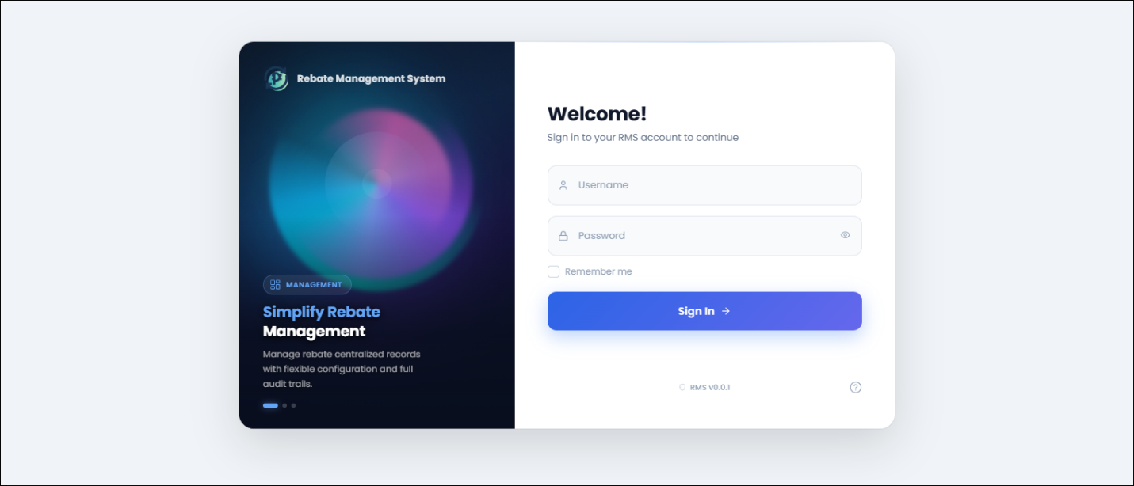

After signing in, the system performs a check
• If true: The user is automatically redirected to /change-password page to update their credentials before continuing.
• If false: The user is redirected to the dashboard.

Password Change Required Page
This page is shown during the user’s first login or when a password reset is required. It prompts the user to set or change their preferred password before they can proceed, ensuring account security and proper credential setup.

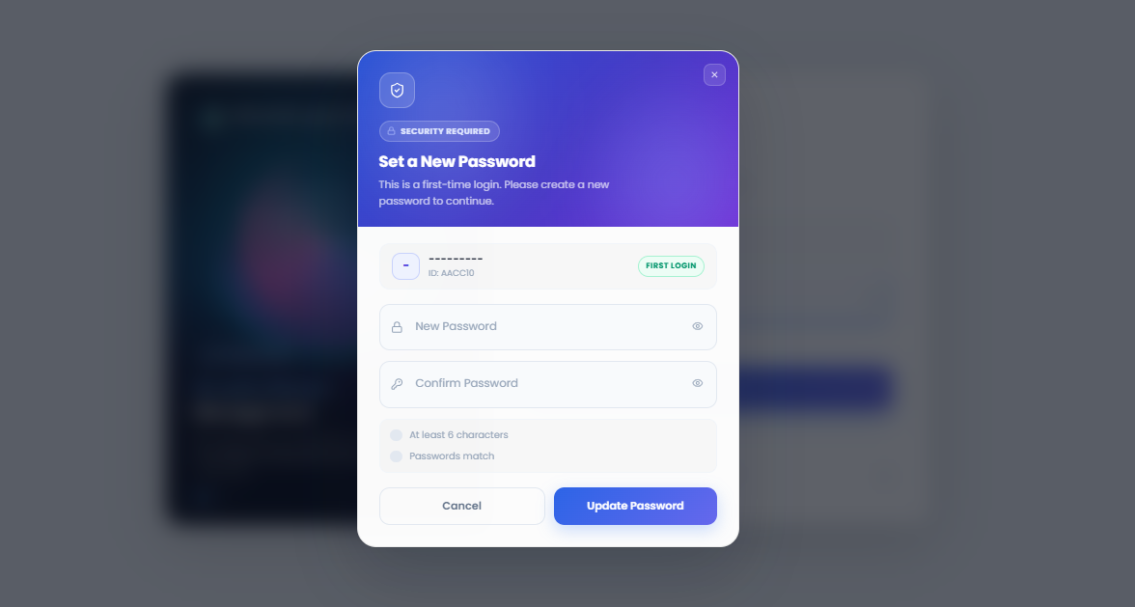

The password setup includes validation rules:
• The password must be at least 6 characters long to meet minimum security requirements.
• The “New Password” and “Confirm Password” fields must match to proceed.
Note: Only when these conditions are satisfied can the user successfully continue to the system.

Landing Page
The Landing Page serves as the main landing page of the system after successful login. It provides an overview of the application and grants access to all available modules based on user permissions.

1
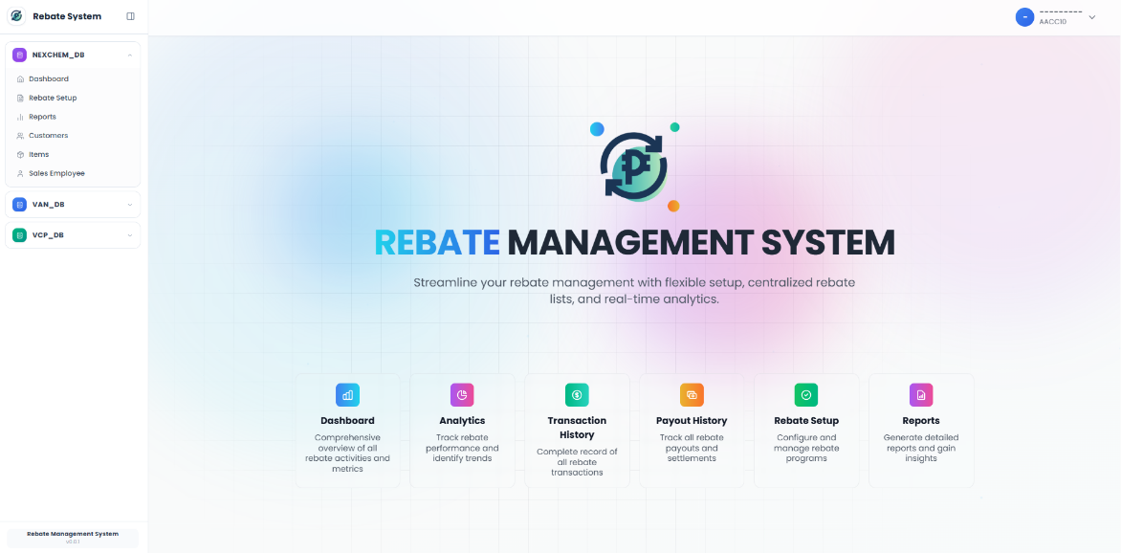
Navigation bar
3
Sidebar

2

Overview Page

Navigation Bar
The Navbar serves as the main navigation hub of the system. It connects layout controls with user-related actions for easy access and usability. It also displays the system or database logo, indicating the current environment the user is working in.
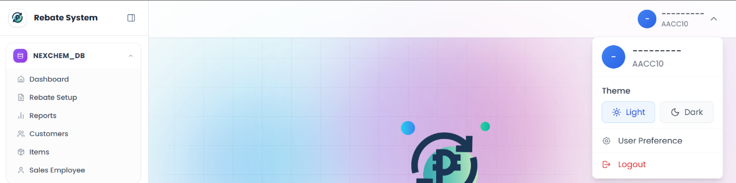

Theme
1

User Preference
2

Theme
The Theme controls the system’s display mode, allowing users to switch between Light Mode and Dark Mode. It adjusts the page colors to improve readability and user comfort based on preference or environment.

User Preference
User Preference refers to the user-specific settings within the system. It allows users to customize their experience by selecting their preferred theme (Light or Dark mode) and arranging the database order based on their usage or priority.

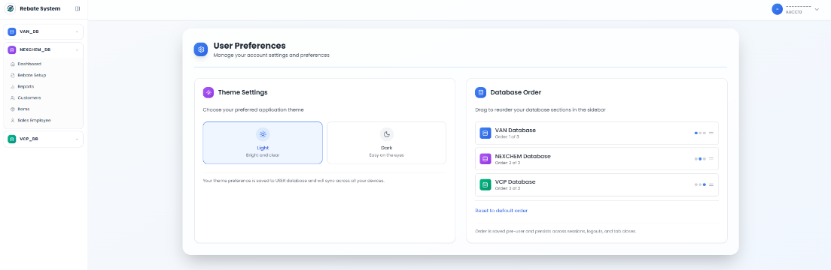

Overview Page
The Overview Page serves as the main landing page of the system. It displays the website title and provides a concise summary of the system’s purpose and functionality. This page allows users to quickly understand how the web application works, including its key features and available modules.

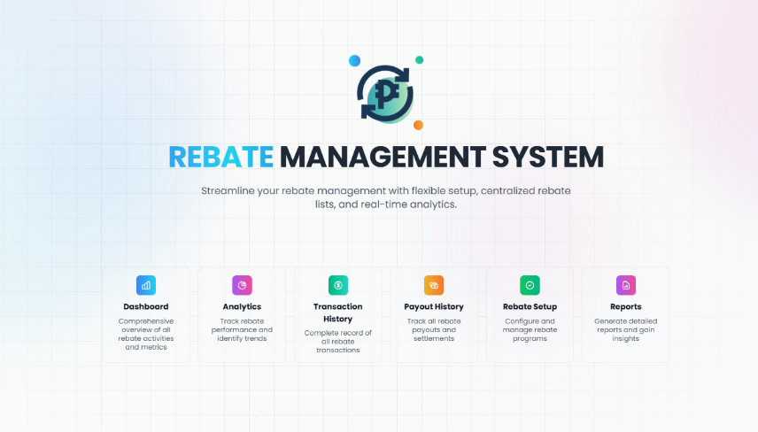

Sidebar
The Sidebar contains the main navigation menu of the system, including modules such as Dashboard, Rebate Setup, Reports, Items, Customer, and Sales Employee. It provides organized access to different features for easy navigation.
For Admin users, the Sidebar displays all available databases, with navigation items grouped in a dropdown structure per database. For users with restricted access, only the database assigned to them is visible, along with its corresponding navigation items.
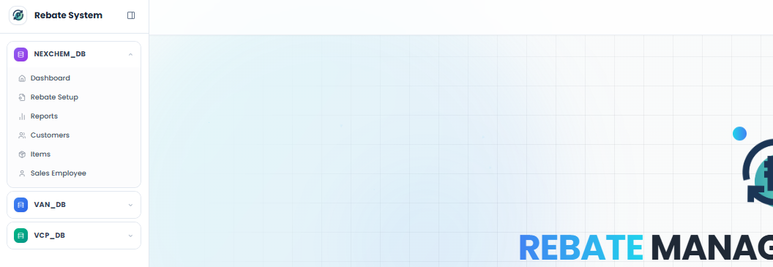

Dashboard
1
Rebate Setup
2
Reports
4
3
Customer
5
Customer
6
Sales Employee

Dashboard
The Dashboard provides an overall summary of the system’s rebate data. It displays key metrics such as Total Rebate Paid, Total Unpaid Rebate, and the number of Active Customers. It also includes a list of rebate details and a status summary, allowing users to quickly monitor performance and track rebate activities.

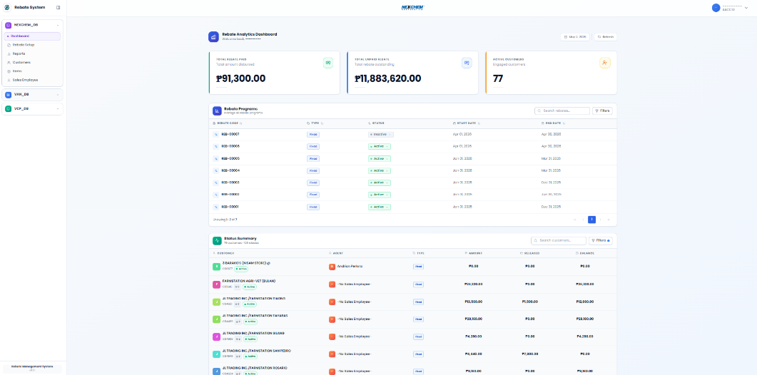
1
Metrics

2
Rebate
Program

3

Status
Summary

Metrics
The Metrics section displays key summary values, including Total Rebate Paid, Total Unpaid Rebate, and the number of Active Customers. It provides a quick overview of the system’s current rebate performance and status.

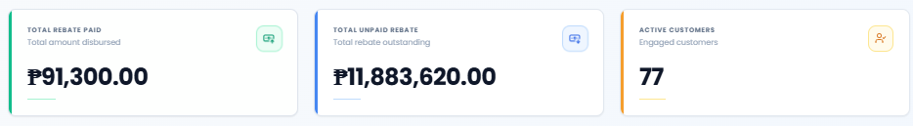

Rebate Program
The Metrics section displays key summary values, including Total Rebate Paid, Total Unpaid Rebate, and the number of Active Customers. It provides a quick overview of the system’s current rebate performance and status.

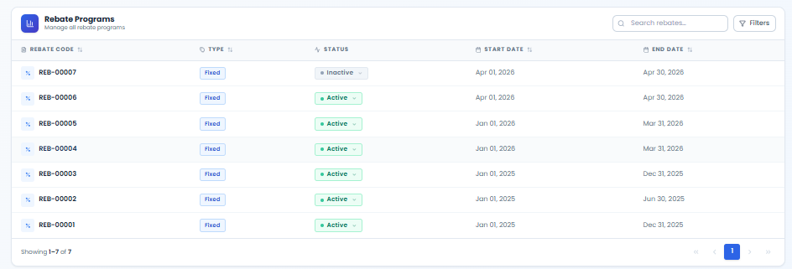

Rebate Program Details (Customers and Items Tab)
In the Customer tab, it shows the list of customers along with their quarterly rebate. If the program is incremental, it also includes the assigned quota.

In the Item tab, it lists the items included in the rebate program, along with their quantity, rebate per unit, and quota range.

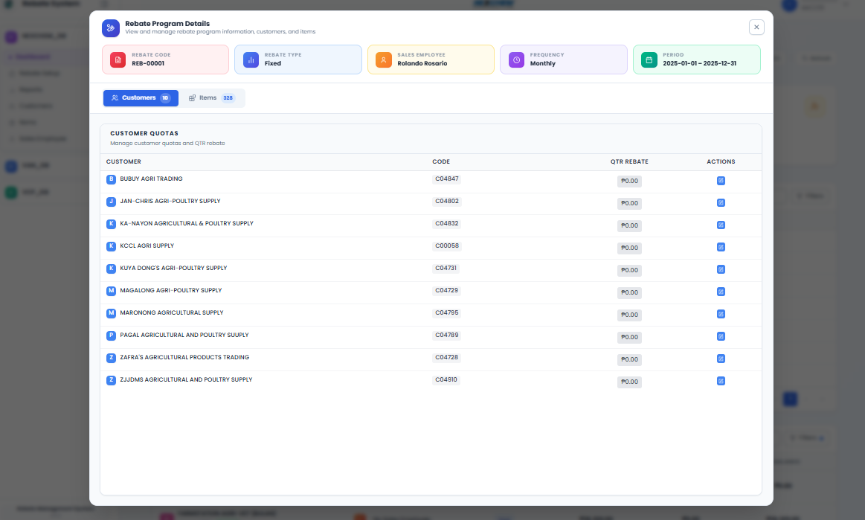

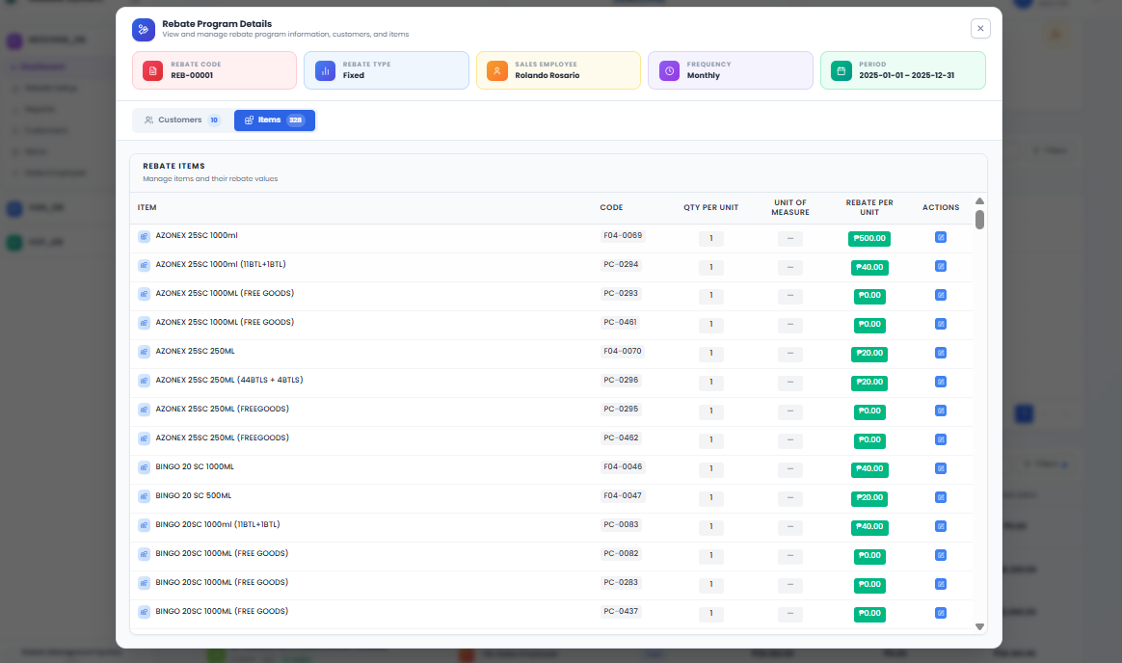

Status Summary
The Status Summary provides an overall view of customers associated with a specific rebate program. The data is grouped by customer, so if a customer has multiple rebate types (incremental, fixed, or percentage), the summary consolidates them, allowing selection by rebate code and rebate type.

It also includes a status indicator to monitor monthly eligibility—whether the customer has earned the rebate. Additionally, the summary displays the Amount, Released, and Balance columns, which track how much the customer has earned, how much has been released in SAP, and the remaining balance.

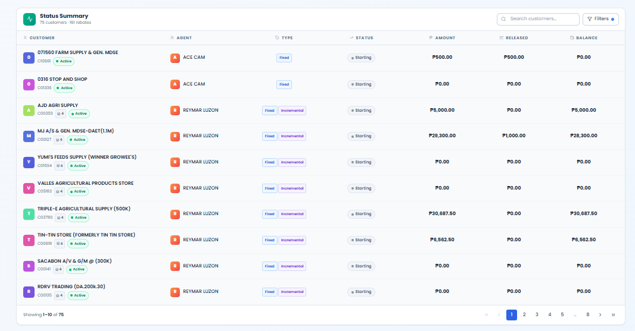

Customer Rebate Code and Type Selection (Customer Details)
When clicking each customer or its details, a modal will show to choose if what rebate code and type

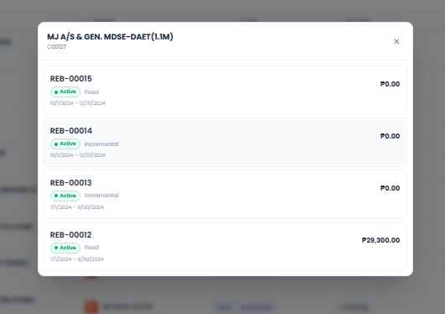

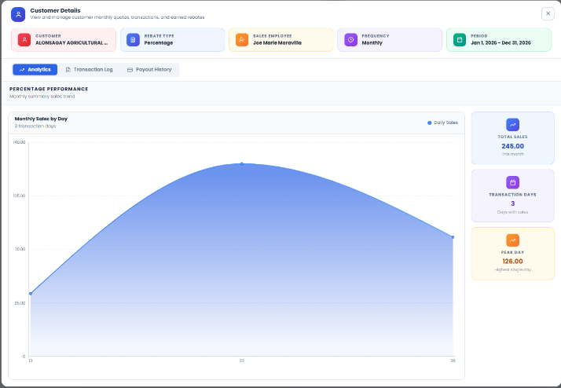
Analytics Tab
The Analytics tab displays a line graph showing the customer’s transaction trends, including the pick date.

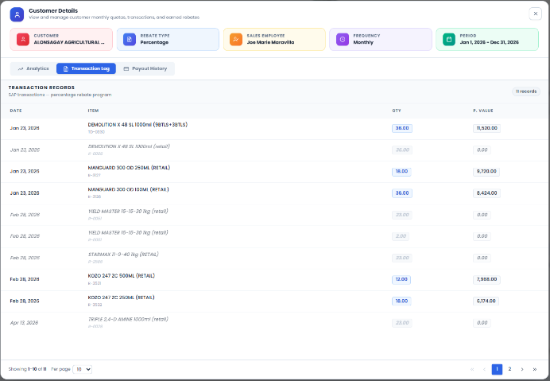
Transaction Tab
The Transaction tab shows all customer item transactions, including the quantity. If a quota is defined, it also indicates whether the transaction is eligible.

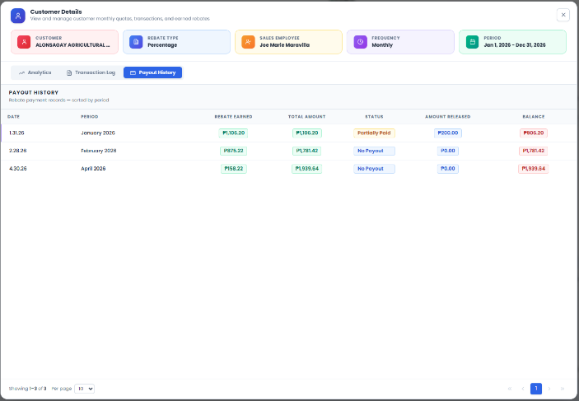
Payout History Tab
The Payout History tab displays the rebates earned by the customer, including the amount released in SAP and the remaining balance.

Rebate Setup
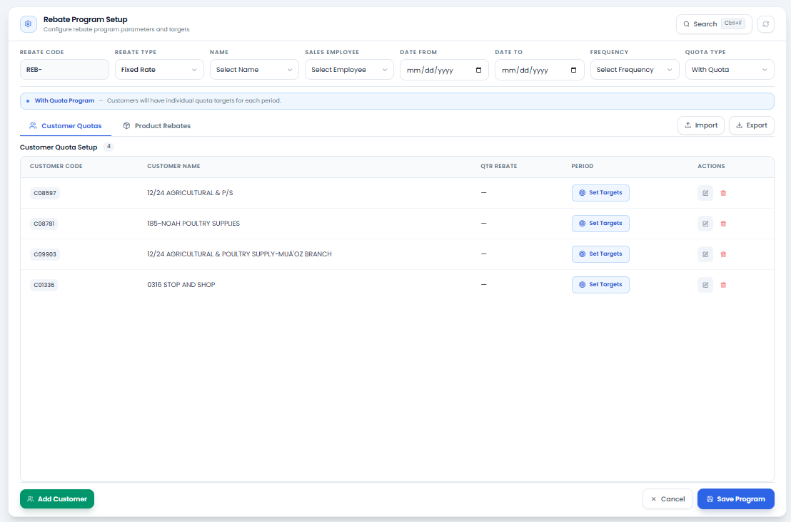

This page is used to configure the rebate program. Users can define the customers, items, and applicable quotas (if required).

Search (Ctrl + F) – This function allows users to search for existing rebate programs and edit them, provided they have the necessary authorization.

Rebate Code – This is an auto-incremented field that generates a new code based on the latest rebate code in the backend.

Rebate Type – This field allows the user to select the type of rebate setup: Fixed, Incremental, or Percentage.

Name – This serves as the label or identifier for the rebate program or items.

Sales Employee – This field represents the selection of sales employees responsible for the assigned customers.

Date From and Date To – These fields define the covered period of the rebate setup.

Frequency – This field specifies whether the rebate is applied Monthly or Quarterly.

Quota Type – This field indicates whether the rebate program or customer is with or without a quota.

Import and Export – This function allows users to import and export Excel files for faster setup.

Customer and Product Tab – Displays the list of customers and products associated with the rebate program, allowing users to view and manage the records included in the program.
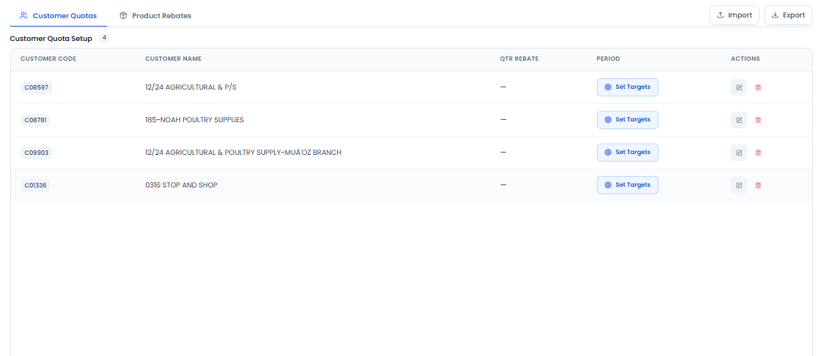

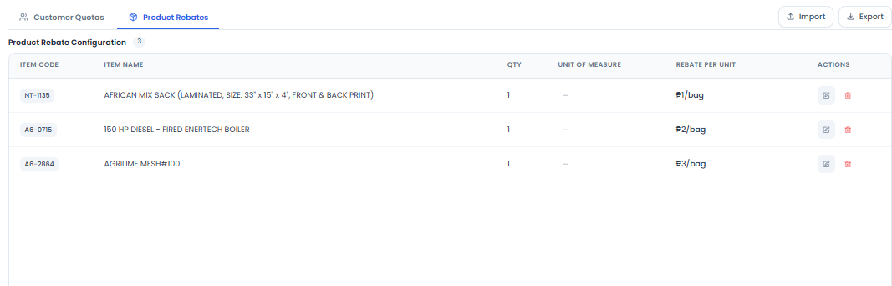

Add Customer/Item – Insert customers or items into the rebate program.

Cancel – Discard unsaved changes and return to the previous state.

Save Program – Save and apply the rebate program configuration and updates.
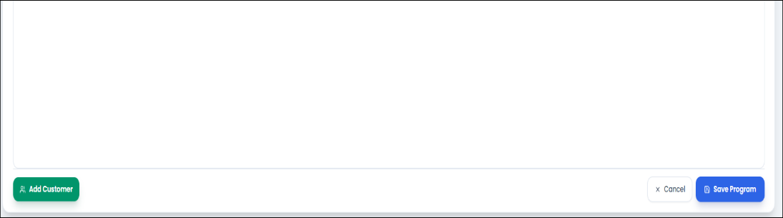

Report
The Report Page enables users to generate customized payout reports based on selected criteria. Users can filter records by Rebate Code, Customer, and a specified date range (From and to dates) to retrieve relevant payout information. The generated report can be viewed on-screen and exported to supported file formats for reporting, analysis, and record-keeping purposes.

Sync Payouts
Allows users to synchronize payout records with the latest data available in the system, ensuring that the report reflects updated payout information.

Export
Enables users to export the generated report to supported file formats for reporting, analysis, and record-keeping purposes.

Rebate Code
Allows users to filter report results based on a specific rebate code, making it easier to view payout information related to a particular rebate program.

Customer
Allows users to filter records by customer, displaying only payout transactions associated with the selected customer.

Date From and Date To
Allows users to specify a date range to retrieve payout records within a particular period, providing more accurate and targeted report results.

Pagination
Provides navigation controls for browsing report records across multiple pages.

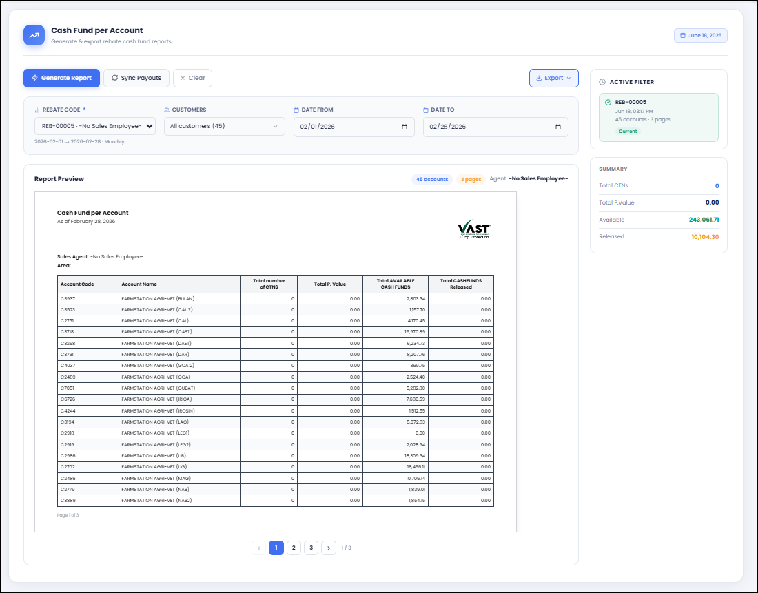

Customer
The Customer Page displays customer records containing the Card Code and Card Name information. It provides filter and search functionalities, allowing users to quickly locate and view specific customer records for easier data management and reference.

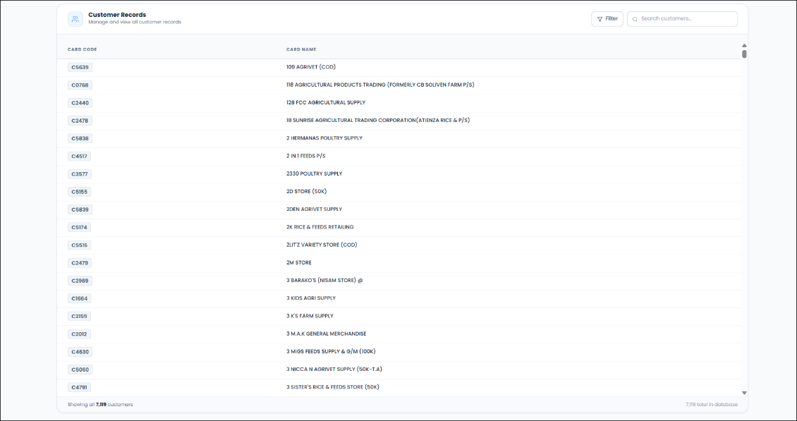

Items
The Items Page displays item records containing the Item Code and Item Name information. It provides filter and search functionalities, allowing users to quickly locate and view specific item records for easier data management and reference.

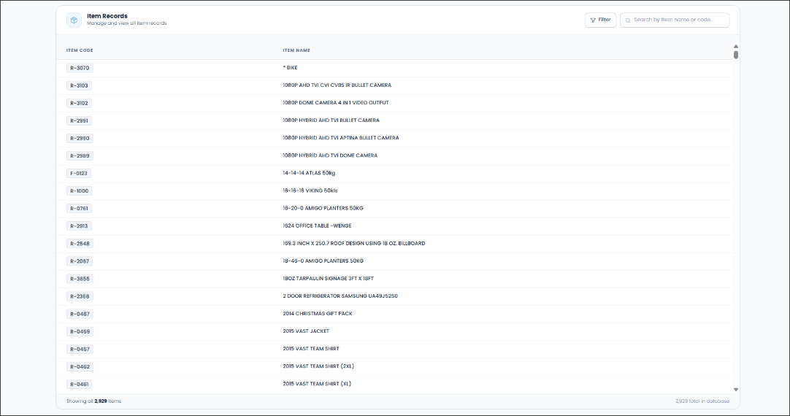

Sales Employee
The Sales Employee Page displays sales employee records containing the Employee Code and Employee Name information. It includes filter and search functionalities, enabling users to efficiently find and view specific sales employee records.
